Code of Behaviour Date
School Name: Edmund Rice Secondary School, Carrick on Suir.
School Address: Mount St. Nicholas, Carrick on Suir, Co. Tipperary.
School Details: ERSS Carrick on Suir is a Voluntary Roman Catholic Secondary School under the trusteeship and the patronage of the Edmund Rice Schools Trust. The School is grant aided by the Department of Education & Skills and is a single sex (boys) school.
School Management: The Board of Management of ERSS Carrick on Suir is a statutory Board appointed pursuant to the provisions of the Education Act 1998.
Mission Statement:
Inspired by its founder, ERSS Carrick on Suir’s mission is to “To provide a caring Christian community which celebrates effort and talent in an environment of hope and happiness", with a vision to “Learn together, succeed together in a respectful environment.”
Ethos:
As an Edmund Rice School ERSS Carrick on Suir seeks to promote the five key elements of an Edmund Rice School as espoused by the ERST Charter:
● Nurturing faith, Christian spirituality and Gospel-based values
● Promoting partnership in the school community
● Excelling in teaching and learning
● Creating a caring school community
● Inspiring transformational leadership
Please Note:
Personal data collected about prospective students/students and their parents/guardians will be retained and used strictly in accordance with the provisions of GDPR legislation as introduced 25th. May 2018. Further details on data protection are set out in the school’s Data Protection Policy.

​

Introduction:

This policy was developed by the Board of Management, staff, parents/guardians and students of Edmund Rice Secondary School. Our school Code of Behaviour is based on respect for oneself, for others and for our environment so that a positive and co-operative atmosphere prevails. The Code of Behaviour applies to all school activities whether on or off campus and on any occasion that the school is being represented. There is a duty and responsibility on all stakeholders in ERSS, students, staff, parents and Board of Management to play their part in developing the positive culture described in this document and to recognise the rights of all to proceed in their roles without threat, danger or obstruction and with the support and respect due to each individual.

As a first step, all new members of the school community should familiarise themselves with the code of conduct, sign up to the code and make effort to ensure they perform their role to the very best of their ability.
​
The following vision statement was developed from suggestions by students from different classes across the school.

Vision

Learn together; succeed together in a respectful environment.

The Aims of our code of behaviour

- Create a caring environment where all students can progress and learn.
- Create a happy and welcoming school environment for all members of the school community.
- Set boundaries to ensure safety, learning and respect for all.

The following standards of behaviour are necessary to make the above vision a reality.

Students are expected to:

- Attend school every day and be on time for all classes.
- Bring all materials and your journal to class every day.
- Wear full uniform.
- Co-operate in the class, follow instructions and do your best.
- Show respect for yourself and all in the school community.
- Not to bring any objects or substances that are likely to cause harm or injury to others or yourself.
- Show respect for school property and the environment.
- Follow all school policies.

​

​

Rule Rationale – Students are expected to

1. Attend school every day and be on time for your classes.
​
This means that:

- You arrive on time for first class and be on time for all remaining classes.
- You will not be allowed to go to your locker during or between classes.
- At 8.55, 11.10 and 1.50 be organised for class and outside your classroom door.
- If you are not in your class you must be able to show that your teacher has given you permission. The teacher concerned will give you a note in your journal.
- If you have an appointment during the school-day then your parent(s) must have contacted the school in advance (note or phone-call).
- All absences must be explained with a written note or a phone-call.

Because:

- Attendance at assembly is essential for school communication.
- The work of the class will be delayed if students are late coming to class or if students need to leave the classroom.
- Good attendance and good time-keeping help you and everyone around you to do well.
- Time missed is hard to make up.

2. Bring all your materials and your journal to class every day.

This means that:

- You need your pens, books, copies and all other relevant materials.
- There is no going out to lockers during class.
- Journals must be brought to every class.

Because:

- Time missed is hard to make up.
- You could delay class if you do not have all materials ready for class
- You need your books to learn.
- You need your copies so that your teacher can assess your work.
- You need your journal to record your homework.

3. Wear full uniform

This means that:

- You arrive to school in full uniform including correct shoes, jumper, shirt and tie – to be worn throughout the school day.
- Jackets / tops to be placed in lockers or coat hangers when you arrive.
- One piercing (stud) per ear is permitted. Facial piercings must be covered.
- Hair should be neat and tidy; not coloured or have a shaved/part shaved appearance.
- Any non-uniform requires a note.
- Uniform should be worn to and from school and at lunchtime.
- Trips outside of school – same rules apply.

Because:

- All students feel part of the ERSS community.
- It helps avoid distraction in a classroom.
- You are representing your school in public.
- Some jewellery can present health and safety concerns in practical classes/PE.
​
​
4. Cooperate in class, follow instructions and do your best.

This means that:

- You follow instructions given in class and follow class rules as negotiated at the beginning of the school year.
- You participate in all aspects of the lesson to the best of your ability.
- You contribute in class discussions, to groupwork, to classroom activities, etc..
- You stay focused and on task.
- Do your best at all times including with homework.

Because:

- It allows for best teaching/ learning for you and others.
- It leads to better learning outcomes for each student.
- You will be less likely to falling behind.
- There will be less chance of accidents, injury or breakages of equipment in practical subjects.
- To reinforce learning during the class.
​

​
5. Show respect to yourself and all members of the school community.

This means that:

- You communicate respectfully to one and other and school all members of staff, This includes verbal, written, text and posts on social media.
- Behave in a way which preserves and enhances your own good name.
- You respect diversity and foster a culture of tolerance.
- You listen to others and use appropriate language.
- You look after your own materials and space keeping them neat and tidy.

Because:
- All members of the school community have the right to work and learn in a safe and respectful environment.
- All members of the school community have the right to be included and reach their potential.
- Offensive or hurtful comments, messages or posts can have serious consequences for all involved.
- Littering and not maintaining the school shows disrespect for those who care for it and you.

6. Not to bring any objects or substances to school that are likely to cause harm or injury to yourself or others.

This means that:

- No smoking is allowed on the school grounds or school environs.
- No lighters, matches or cigarettes allowed in the school.
- No objects that can cause harm to others are allowed in the school.

Because:

- The wellbeing, health and safety of all students, staff and visitors are of the utmost importance.
- The law needs to be followed, smoking on public premises is illegal.
- It is harmful to students and others.
- Can cause damage to school property.
​
​
7. Show respect for school property and the environment.

This means that:

- Classrooms, GP, Locker area, toilets and dressing rooms are kept clean and tidy.
- You do not damage or deface school property.
- All rubbish is put in bins provided.

Because:

- You should have pride in your school.
- Everybody has the right to work study and learn in a clean environment.
- It is expensive to maintain the school and keep it clean.
​
​

8. Follow all school policies including Anti-Bullying Policy and Mobile Phone policy/ Social Media and ICT policy.
​
This means that:
​
- You are aware of how to behave in a responsible way with social media sites and mobile phones.
- That you realise that it is illegal to take photographs or record material or send messages or post material on social media sites which is offensive or causes annoyance or needless anxiety to a person.
- You do not bully or victimise other students and you report instances of bullying to the Relevant Teacher (Principal, DP or Class Teacher)
- Your mobile phone, if brought onto school premises, should be switched off and put in your locker unless otherwise directed by your teacher.

Because:

- Bullying can cause hurt and upset and can have a negative effect on the wellbeing of others.
- Using phones and other devices to record members of the school community is an invasion of privacy and is contrary to GDPR legislation.
- Mobile phones are distracting and interrupt teaching and learning.
- Classes should be free from interruptions.
​
​
​
Standards of Behaviour

This table was developed by students. It lists the behaviours which students expect of each other inside and outside the classroom for the good of everybody.

Behaviour Expectations:
Be Respectful
Be Ready
Be your Best and Reach your potential
​

Classroom

- Raise your hand and wait
- One Voice
- Enter the classroom quietly
- Follow instructions and listen to others
- Allow others to learn and achieve
- Bring your books, copies and equipment to class
- Attend all classes and be on time
- Wear full uniform
- Participate and concentrate in class
- Complete classwork and homework to the best of your ability
​

Corridors / Lockers / GP
​
- Keep the locker area clean and tidy
- Respect others and their personal space
- Put all waste in the designated bins
- Be organised and visit lockers at designated times
- Go directly to class and be on time
- Be mindful of others and step back to let people pass
- Keep noise levels low
- No running, pushing or shoving in corridors

Toilets / Changing Rooms
​
- Respect people’s privacy and school property
- Eating is not allowed as it is unhygienic
- Use of mobile phones not permitted
- Use toilets at designated times and be on time for class
- Get changed quickly and be on time for class
- Have necessary equipment for PE class
- Leave toilets and changing area in the condition you wish to find them
- Spray aerosols away from others
- Clean boots and shoes before entering
​
Yard
​
- Put litter in the bins provided
- Respect school property
- Teachers car park is out of bounds
- Keep to the lower yard for sports
- Go directly to class when bell rings
- No fighting or rough play
- Use the pedestrian entrance

Teachers and School Staff
The example set by teachers and all school staff has a direct bearing on learning for students. They have a responsibility to model the school’s standards of behaviour in their dealings both with students and each other.
Parents/Guardians
- The school believes the full support of parents/guardians for the Code is essential. Values at home and parental attitude make a positive contribution to student’s learning and behaviour. Parents/guardians are expected to model the standards that students are asked to respect.
- The school maintains regular communication with parents/guardians and if necessary, parents/guardians will be invited to discuss their child’s behaviour, with the objective of achieving an agreed common approach.
- The school needs parents full support in promoting public health advice, and school-generated guidelines and protocols to manage the Covid-19 public health situation.

Promoting Positive Behaviour
Promoting positive behaviour is a main objective of the school’s Code of Behaviour. Through it ethos, policies and practices, ERSS actively promotes positive behaviour and seeks to prevent inappropriate behaviour.
The school is actively committed to consistency in promoting good behaviour. This can be achieved by mutually respectful relationships between student and teacher.
- Students are given responsibility and are encouraged to understand why the Code is important.
- The Code is made to work in a fair and consistent way.
- Standards are clear, consistent, and widely understood and high expectations are set.
- The school climate and atmosphere are created by the actions of everyone who is connected to the school: teaching staff, other staff, parents/guardians and students.
- Parents/Guardians, students and teachers are invited to be involved in seeking to promote good relationships and a harmonious atmosphere through positive interaction.
- Adults model the behaviour expected from students.
- Clear boundaries and rules are set for students.
- Students are helped to recognise and affirm good behaviour.
- Positive feedback is provided through the school journal where merited.
The school acknowledges, promotes, and rewards good behaviour in a variety of ways. This includes the following:
- Verbal praise in class.
- Positive points are logged on VS Ware. See Appendix 1 for a list of behaviours recognised on VSware.
- Compliment certificate/letters of excellent behaviour are awarded to students who achieve a minimum of 10 positive points by the school management.
- Student of the week – nominated by teachers through VSware, students will receive a prize in recognition of their efforts.
- Rewards given at various times, at the discretion of the year head, Deputy Principal and Principal e.g. Positive points parties to well behaved students.
- Regular assemblies reinforcing and encouraging positive behaviour.
- Christmas and Summer Reports.
- Directly from teachers, year head, Deputy Principal(s) and Principal communicated through notice boards, intercom, newsletter and school twitter and website.
- Annual award ceremonies.

Response to Negative Behaviour
It is the responsibility of the school authorities to:
- To maintain a classroom and school environment which is safe for students, teachers and other school staff.
- To maintain a classroom and school environment that is supportive of the learning of every student and ensures continuity of education.
It is the policy of the school to intervene early and positively when a student’s behaviour does not meet standards expected.
Sanctions
In the event there is a break down in the Code of Behaviour, sanctions will be imposed. In order to ensure fairness and proper procedures, the following ladder of referral will be operated in the school:
Sanction | Imposed by
- Verbal warning and/or extra working being assigned. | Classroom teacher
- Communication with parent/guardian via homework journal, e-mail or telephone call home | Classroom teacher
- * Negative points being assigned on VSware | Classroom teacher
- Three reports on VSware i.e. -6 points – meetings with student & contact with parent/guardian | Year Head
- Five reports on VSware i.e. -10 points – Friday detention  NOTE: Failure to attend detention without prior notification to the Year Head is a serious breach of the Code of Behaviour and will result in further sanction | Year Head
- Seven reports on VSware i.e. -14 points – meeting between parents, student, Year Head and Deputy Principal. **Student will then be place on a report card to monitor behaviour and application in class. | Year Head & Deputy Principal
- Ten reports on VSware i.e. -20 points – in-school suspension. A meeting with parents and school management and a behavioural management plan will be developed. | Deputy Principal
- If a student exceeds -20 points, a further meeting with parents/guardians will be called and an out of school suspension may be imposed. | Principal
Please note:
- Students who receive multiple points will not be considered for selection for extra/co-curricular activities.
- Students who fail to adhere to the safety rules in practical classes may be removed permanently from the subject following consultation with parents. A reduced curriculum may then need to be followed.
- Students who are judged to be a risk at break times and/or are failing to follow instructions of supervisors may be sent home at these times and placed under the care of their parents/ guardians.
- Following a breach of the school code of behaviour students may be withdrawn from class, if deemed necessary by school management to allow time for investigations to take place.
- Serious breaches of the Code of Behaviour may result in referral to external agencies or to the Gardai.
- Referrals may also be made to the Board of Management for permanent exclusion.

Serious Incidents of Misbehaviour
Each case will be judged on its own merits, and any of the above stages may be omitted when deemed appropriate by the school authorities. In cases of serious misbehaviour for example, when the authority of a teacher or the school is seriously challenged, if the school has been brought into disrepute or if normal civil law has been breached, the Principal or Deputy Principal will deal with the matter in the first instance. Suspension, exclusion or other sanctions, at the discretion of management, may be considered as a first option. Furthermore; the Principal, the Deputy Principal, or a year head may choose to intervene at any stage of the discipline process when this is deemed to be necessary or helpful. Generally, in the case of such incidents, a student will be asked to write a detailed account of the incident. Students may not be allowed to attend class during the investigation. The purpose of this is to provide the student with the opportunity to reflect on his or her behaviour and its implications for oneself and the rest of the school community. When investigating an incident which may lead to a lengthy suspension or exclusion, the following procedures will be adopted by the Principal:
- The student or students involved in the incident will be interviewed.
- The allegations against the student will be outlined and his/her responses noted.
- The student will be asked to fill out a written report on the incident.
- Other members of the school community, e.g. staff, students etc. may be interviewed as deemed appropriate. Written reports may be sought and notes taken at interviews will be kept on file for future reference.
- Parents/guardians will be asked to come to the school to meet the year head / Deputy Principal / Principal who will outline the case to them and the pupil. Once again, responses will be noted.
- The Principal in consultation with the Chairperson of the Board of Management will then decide the sanction (if any) to be applied.

Procedures for Suspension and Expulsion:
Suspension is defined as a sanction requiring the student to absent himself from the school for a specified, limited period of school days. Suspension from school is a serious disciplinary measure. The Management of the school reserves the right to suspend a student where the continued presence of that student threatens the education or the health and safety of other student(s) or staff members or where the student is responsible for serious damage to property.

All individuals have the right to be treated fairly and with dignity, in an environment free from disruption, intimidation, harassment and discrimination.

A single incident of serious misconduct and breach of the rules may be grounds for an immediate suspension.
Such breaches would include:
- Fighting or assault or violence.
- Refusing to submit a phone or recording device.
- Physical or sexual assault.
- Bullying or harassment.
- Threatening behaviour.
- Reasonably suspected possession or dealing in drugs, alcohol, addictive substances (unprescribed drugs) or illegal substances.
- Reasonably suspected of being under the influence of drugs, alcohol, un-prescribed drugs or illegal substances.
- For refusing/failing/being unwilling to assist staff in the investigation of incidents of misbehaviour
- Serious damage to property.
- Smoking, including e-cigarettes, vaping within the school campus.
- For behaviour that undermines public health advice, and school-generated guidelines and protocols to manage the Covid-19 public health situation. For example,
  - Failing or refusing to wear a face covering.
  - Failing or refusing to follow cleaning and hygiene etiquette such as washing hands, hand sanitiser, cleaning surface.
  - Failing or refusing to practice social distancing.
  - Failing or refusing to follow etiquette around coughing, sneezing, spitting etc.

This list is not exhaustive.

Suspension will normally only take place after all the other disciplinary procedures have been exhausted or in a situation where, due to the seriousness of the incident, suspension of the student is considered necessary or as a result of a number of incidents where other sanctions have failed. The Board of Management of ERSS has delegated the power to suspend for a maximum of 3 days to the Principal. A suspension of 4 or 5 days may be imposed by the Principal with the prior approval of the Chairperson of the Board of Management. A suspension of 5 days and not more than 10 days can only be imposed by the Board of Management.

In addition, any suspension that would bring the total number of days for which the student has been suspended in the current school year to 20 days or more must be formally reviewed by the Board of Management and notified to the Educational Welfare Officer.

Fair procedures will be followed by the school when proposing to suspend a student. The school’s procedures will have two essential elements:

• The right to be heard: The Principal will inform the student and his parents of the alleged misbehaviour, how and by whom it will be investigated and that it could result in suspension. The student and his parents will be given an opportunity to reply to the allegations before a decision is made and before any sanction is imposed.
• The right to impartiality: This requires that the investigation of the alleged misbehaviour is separated from the process of making a decision with regard to imposing sanctions. Therefore, the Principal will arrange for another member or members of staff to conduct the investigation and to present a full report on the facts of the case, as well as any other relevant information to the Principal. The principal will then decide whether to impose a suspension on a student.

If a suspension is imposed the following procedures will be followed:
  - The student and his parent(s) will be informed of the suspension by registered post. This letter will state the duration of the suspension the reason(s) for the suspension, a statement that the pupil is under the care and responsibility of the parents/guardians while on suspension. If consideration is being given to proceeding to expulsion, it will be clearly stated in the letter.
  - Parents will be informed in the suspension letter of their right of appeal to the Board of Management.
  - Parents will be informed in the suspension letter of their right of appeal to the Department of Education and Skills if the suspension brings the total number of days suspended in excess of 20 school days for the current school year.
  - The Board of Management is informed of the suspension.
  - If a serious breach of discipline occurs then a student may be removed immediately from class and placed in the care of a member of staff until such time as he can be handed over to the care of his parents.
  - The principal or deputy principal will meet with the student and his parent(s) on the student’s return to school after suspension to discuss the school’s expectations regarding the student’s behaviour and how these expectations may be realised.

Suspension may be removed under the following grounds:
- The Principal/ Board of Management agree that another sanction be applied after discussion with the parents/guardians.
- Successful appeal to the Board of Management.
- Successful Section 29 Appeal.
- New circumstances come to light.

Role of the Board of Management:
A student and his parent(s)/guardian may be called to meet with the Board of Management to discuss deviations from the Code of Behaviour. In such instance, the Board of Management will consider what sanctions (if any) should be imposed up to and including expulsion. In certain circumstances, the Board may decide to put the student ‘on licence’.

This will involve the following:
1. A contract will be drawn up between the Board, the student and his parents and a clear set of expectations will be set out for the pupil as part of the contract.
2. The pupil will collect a report form on a daily basis before 08.55am from the Principal. He will get it filled in by each of his teachers for that day, get it signed by the Principal and bring it home for his parent or guardian to sign. This form must be returned to the principal the following morning.
3. The Year Head and the Principal will monitor the comments on the report form and the Principal will give an update to the Board on the student’s progress while on licence at subsequent Board meetings.
4. The student will continue ‘on licence’ until the Board considers otherwise. If the student’s progress is satisfactory, the Board may decide to remove the sanction from the pupil. In the event of the student’s behaviour not improving under licence or should there be other serious breaches of the school’s Code of Behaviour, the Board may decide to meet with the student and his parents/guardians again, where sanctions up to and including expulsion will be considered.

Expulsion:

Expulsion is a final and last resort when no other solution is possible and all other forms of discipline and attempts at rehabilitation have been exhausted. However, the following behaviours (not an exhaustive list) may be grounds for expulsion, even for a first offence.
• Violence or physical assault of a member of the school community
• Threat of violence against a member of the school community
• Supplying illegal drugs to other students in the school
• Sexual assault of a member of the school community
• Destruction of or attempted destruction of school property

When the Board of Management is considering expulsion, the following procedures will be followed:
1. Parents will be informed by registered post as to the time date and location of the Board of Management meeting to discuss the student’s behaviour.
2. Parents will be informed of the reason why expulsion is being considered and will be invited to attend the meeting to represent their son.
3. All relevant documentation regarding the pupil shall be presented at the Board meeting and also details of what interventions and disciplinary procedures were carried out in the past. Copies of relevant documentation will be sent to the parents/guardians in advance of the meeting with the Board of Management.

If the Board decides to recommend an expulsion of a student, the following procedures will be followed:
1. The parents/ guardians will be notified by registered post of the Board of Management’s decision to recommend an expulsion and the next steps in the process.
2. The Board of Management will notify the Education Welfare Officer of the decision and consultations on the matter will take place.
3. The parents/guardians will be informed of their right to appeal and will be assisted with the appeal process.

Interventions
In ERSS we recognise the need for support for pupils experiencing difficulties for whatever reason. The following may be involved in supporting/helping students through any difficulties:
  - The Principal;
  - Deputy Principal;
  - Year Head;
  - Subject Teacher;
  - Guidance Counsellor;
  - School Chaplain;
  - Pastoral Care Team;
  - Student Support Team
  - Learning Support Team;
  - NEPS Psychologist (National Educational Psychological Service);
  - Critical Incidence Team;
  - TUSLA (Child and Family Agency);
  - HSE (Health Service Executive);
  - Any other relevant support.

Appeals
A student who is expelled has the right to appeal the expulsion (Education Act, 1998, Sec 29) to the Secretary General of the Department of Education and Skills. An appeal may also be brought by TUSLA on behalf of a student.
Further details about the appeal process, including documentation, is available on the DES website.

CCTV Systems Protocol
CCTV systems are installed both internally and externally in ERSS for the purpose of enhancing security of the building and its associated equipment as well as creating a mindfulness among the occupants, at any one time, that a surveillance security system is in operation within and/or in the external environs of the premises during both the daylight and night hours each day. CCTV surveillance at the ERSS is intended for the purposes of:
- Protecting the school buildings and school assets, both during and after school hours;
- Promoting the health and safety of staff, pupils and visitors;
- A deterrent against bullying;
- Reducing the incidence of crime and anti-social behaviour (including theft and vandalism);
- Supporting the Gardaí in a bid to deter and detect crime;
- Assisting in identifying, apprehending and prosecuting offenders;
- Ensuring that the school rules are respected so that the school can be properly managed.

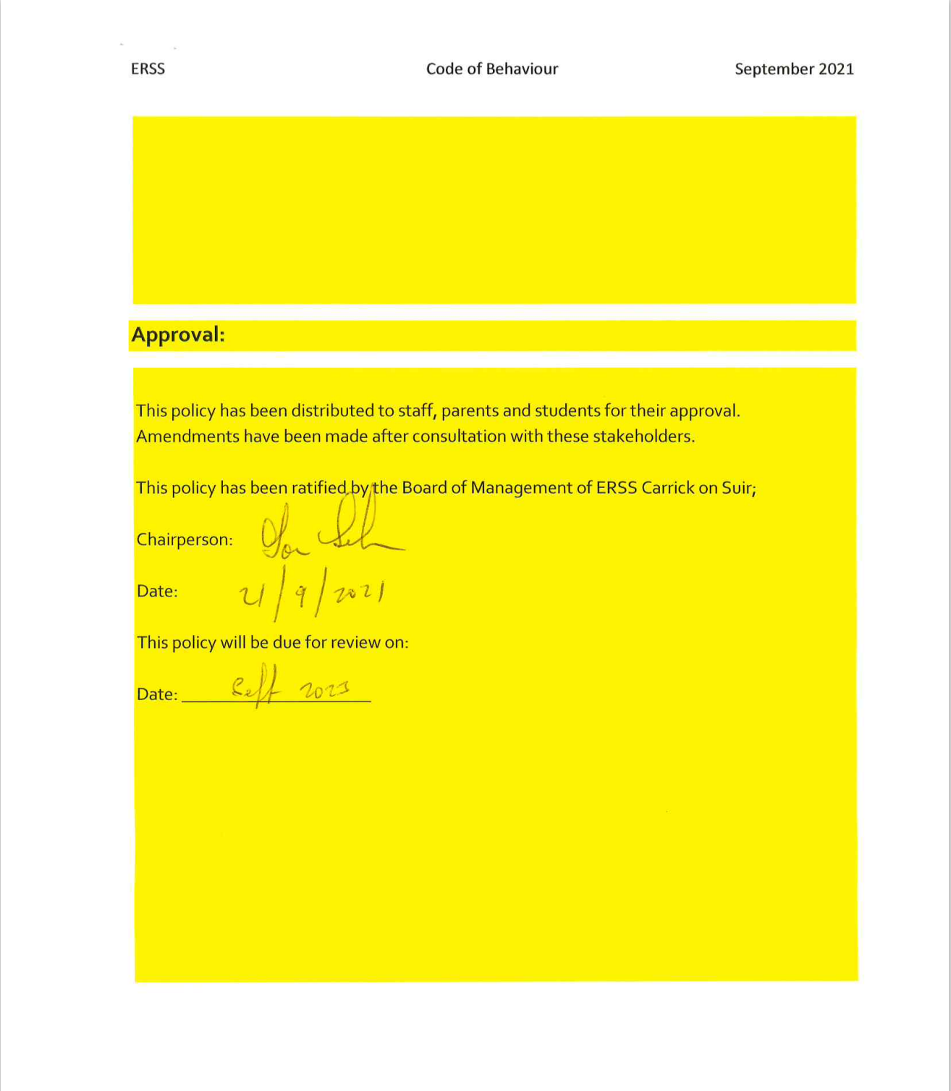

Appendix 1:

Positive and Negative Points System

Positive Behaviour Recognised | Points | Negative Behaviour Recognised | Points
Excellent participation in class | 2 | Following verbal warning and communication home – continued disruption to Teaching & Learning | - 2
Excellent effort in homework/project work | 2 | Following verbal warning and communication home – continued failure to attempt homework and/or project work | - 2
Showed improvement in class | 2 | Unsatisfactory uniform – Year Head/ SMT only | -2
Helpful and co-operative with teachers | 2 | Following verbal warning and communication home – continued inappropriate behaviour on corridor/outdoors | - 2
Excellent participation in extra\co-curricular activities | 2 | Following verbal warning and communication home – continued lateness for class
Enhanced the learning of others in class | 2 | Non- attendance in class without permission | -4
Displays excellent school spirit | 2 | Leaving School without permission (Friday detention) | -10
 |  | Mobile phone being used without permission (Friday detention). | -10

Please note the following behaviours are not included in the points system and will be addressed under - Serious Incidents of Misbehaviour:
- Abusive or physical aggression towards staff or other students;
- Failure to submit a mobile phone when asked to be a member of staff;

